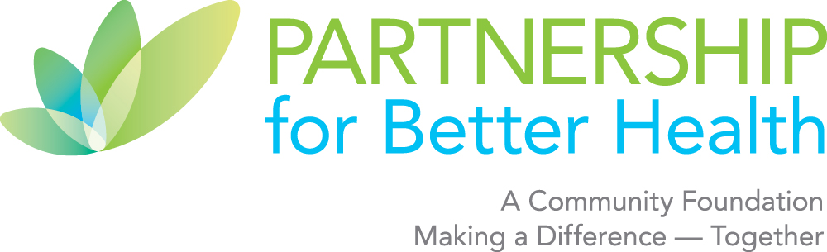

- REQUEST FOR PROPOSALS —
Strategic Plan Refresh for Community Health Foundation
Due: October 3, 2025

Project Summary & Background

The Partnership for Better Health is a nonprofit community foundation that works collaboratively with key stakeholders throughout Central and Western Cumberland County, Perry County, Northern Adams County and Greater Shippensburg. Founded in 2001, our mission is to champion and invest in ideas, initiatives and collaborations to improve the health of the people and communities in our region. We achieve this through a blend of strategies that include strategic grantmaking, policy advocacy, nonprofit capacity building and public education about key health issues.

The Partnership for Better Health is seeking proposals from interested consultants and firms to guide a refresh of our current strategic plan to be implemented starting July 1, 2026. We seek a consultant that can engage us in reflecting on what we have accomplished thus far, how we can build on the momentum, and identify what we still need to do to fulfill our goals:

Goal 1: Create equitable and inclusive organizational policies and practices.
- Cultivate an organization that encompasses comprehensive policies and practices that uplift, empower and involve justice, health equity, diversity, inclusion and belonging in internal operations and culture.
Goal 2: Build equitable, just, and inclusive community investment processes.
- Part A: Build an equitable and inclusive community investment process consisting of grants and initiatives.
- Part B: Build an equitable and inclusive community investment process consisting of Community Engagement, Partnerships and Policy Advocacy.
Goal 3: Center People with Lived Experience (PWLE) in building community health solutions.
- Center people with lived experience in building healthier communities.

- ELIGIBLE APPLICANTS: Applicants should demonstrate a proven knowledge of strategic planning for nonprofit organizations, and a depth of expertise in the fields of community health and philanthropy. Experience with expertise in grassroots community engagement, consensus building and development of aspirational and measurable strategic plans is required. Experience in working with organizations that are committed to centering people with lived experience is a plus.

- CONSULTING ROLE: The selected consultant(s) will be asked to work closely with the foundation’s board and staff to: 1) swiftly understand the current strategic plan, accomplishments, challenges, and capacities; 2) solicit the input of board members, volunteers, staff and key partners of the foundation to incorporate their priorities into an inclusive planning process; 3) document key findings and work collaboratively to shape major recommendations; 4) lead the foundation in crafting a multi-year refreshed strategic plan with measurable goals and objectives; 5) consider optimal organizational structure and committees to support the new plan; 6) provide a strategic roadmap or similar visual to communicate the refreshed plan.

The Partnership for Better Health seeks to update our existing strategy and establish forward looking goals that are grounded in what our communities most need from our organization at this time. Some foundational work to prepare for strategic planning is already available. For example, the results of our health systems’ community health needs assessments are available through our three major health systems, Penn State Health, UPMC Pinnacle, and Wellspan, as well as our local community action agency. Your additional suggestions regarding proposed steps and overall approach are welcomed and encouraged.

Upon request in drafting your proposal, the Partnership can provide the original strategic plan, accomplishments and challenges for 2023-2024 and 2024-2025, as well as a draft action plan for 2025-2026.

- TIMELINE: The Strategic Planning process is expected to last three to five months, beginning in November 2025 and concluding in March 2026. Some meeting times may be flexible and based upon the consultant’s proposed approach.

- BUDGET: Budgets are expected to range between $5,000 and $10,000.

Proposal Requirements & Contact Information
Proposals do not need to be lengthy and may be 7 pages or less (excluding biographies and references). Please include the following components:
- Qualifications: Individual and/or firm profile, length of time engaged in community work, and examples of recent relevant projects. A summary explaining why you/your group is well qualified for this project.
- Biographies for key individual(s) leading the project.
- Approach: Description of the consultant’s interest in this project and proposed approach to complete the work described herein.
  - Why are you interested and what will be achieved?
  - What are your proposed strategies to complete the strategic plan refresh? What project management methods will you use?
  - How will our values be incorporated into your strategic planning refresh process?
  - How will the final refreshed strategic plan be structured and measurable over multiple years?
  - What other resources are you able to offer, such as unique design features and measurement tracking methods?
- Timeline: Confirmation of the individual’s or firm’s availability to begin the project in accordance with the proposed schedule (see below), noting any additional project activities, if desired.
- Budget: Please submit a simple budget and/or budget narrative confirming use of funds.
- Three References: Include name, affiliation/relationship, address and phone number.

Bidding Process: Proposals may be submitted via email to Casandra Jewell at: CJewell@ForBetterHealthPA.org. Please feel free to direct possible questions about this RFP to Carol Thornton (717-960-9009 x7).
- Confirmation: You will receive an email confirming our receipt of your proposal within one business day. If you have not heard from us by then, please call us directly so that we can ensure we have received your materials (Casandra: 717-960-9009 x0).

Proposed Project Timeline
Release of RFP | August 22, 2025
Proposals Due | October 3, 2025
Finalists Notified | October 17, 2025
Finalist Interviews | October 20-27, 2025
Selection Announced | November 1, 2025
Anticipated Start Date | November 15, 2025
Tentative Meeting with Board | December 9 at 4:30 pm
Anticipated Completion Date | March 31, 2026

Selection Process
A workgroup comprised of community volunteers, Partnership for Better Health board members and staff will consider each proposal carefully and base its selection on the following steps.
Step 1: Review of Qualifications
The workgroup will determine which groups or individuals are best qualified to complete the project based upon quality of proposals, fit with priorities described above and expertise in Strategic Planning.
Step 2: Interviews with Finalists
The workgroup will invite finalists to meet with us and make a presentation of their proposed approach and desired outcomes. The workgroup reserves the right to determine the number of finalists and anticipates that 2 to 3 individuals/groups will be selected for interviews.
Step 3: Calls to Listed References

